[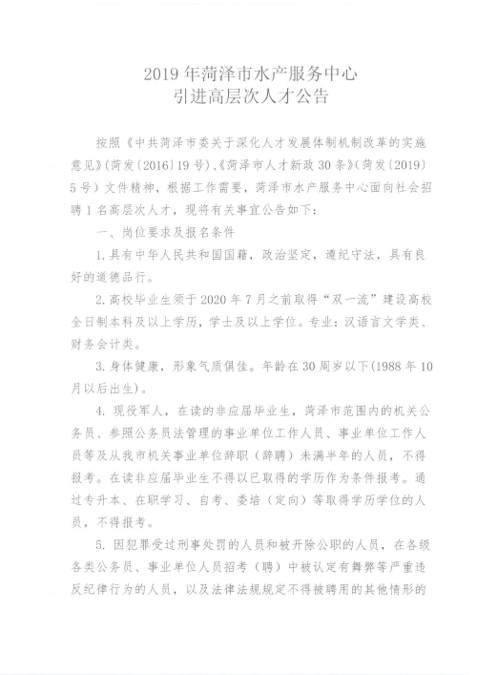](http://hzsc.heze.gov.cn/picture/0/dd09e180ea9d42fe9314da5ae6041f5d.jpg)

[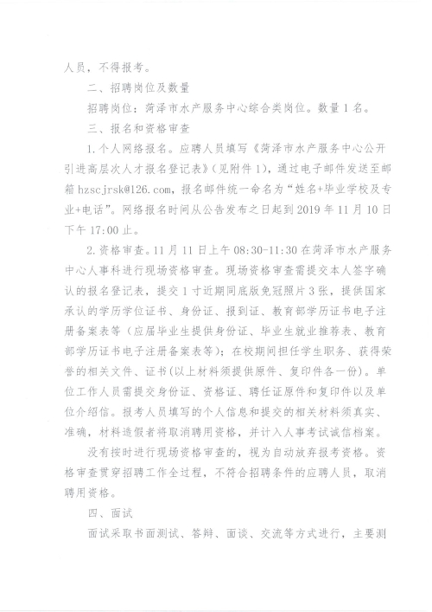](http://hzsc.heze.gov.cn/picture/0/46af70b515e84aacb471ff43d6ab0895.jpg)

[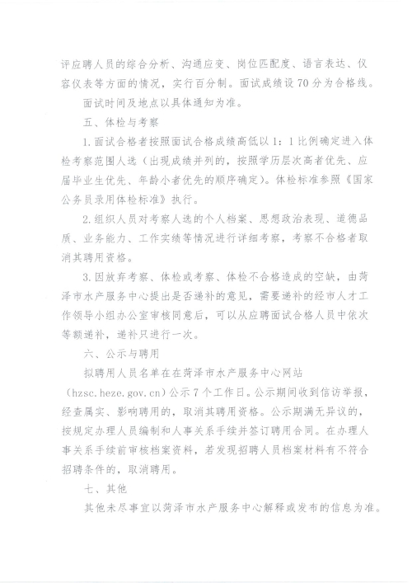](http://hzsc.heze.gov.cn/picture/0/9a6691781fed44e5a60af9f579230467.jpg)

[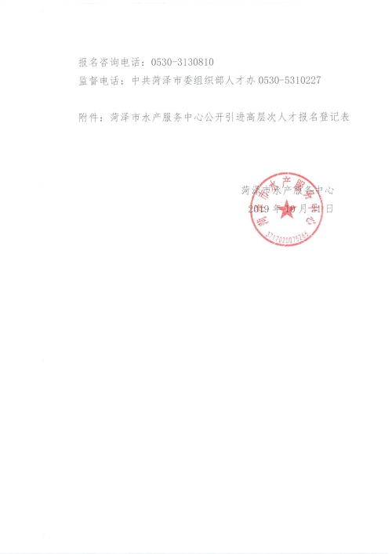](http://hzsc.heze.gov.cn/picture/0/642e5165e4bc416e86901c70bebe97e9.jpg)

[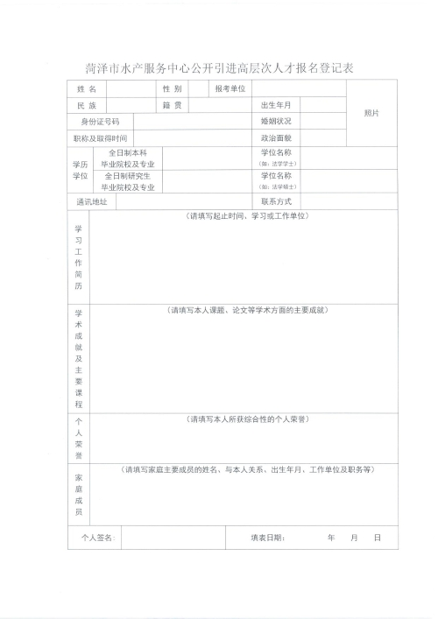](http://hzsc.heze.gov.cn/picture/0/a20d549968dd401d9c310c0da8959175.jpg)