[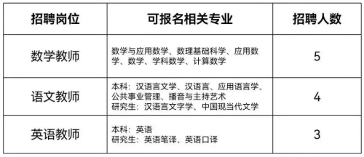](http://www.bzjsxy.cn/picture/0/2f41cc4b20634edabf6ace9d994641be.jpg)  
[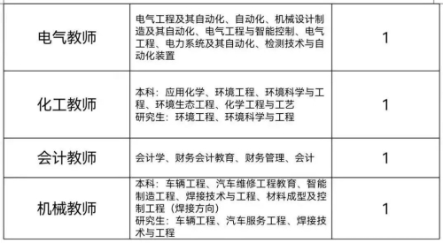](http://www.bzjsxy.cn/picture/0/c33bec68a6e342ceb8dedb97d4a44934.jpg)