[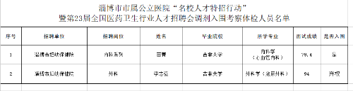](http://ws.zibo.gov.cn/picture/0/a286e3f5e28e4e7ca0f71758175ca270.png)